|  |  |  |
| --- | --- | --- |
| **COMP1787 (2023/2024)** | **Requirements Management** | **Contribution: 100% of course** |
| **Module Leader:**  **Dr. Aditi Rawal** | **Coursework Term 2 (collabs)** | **Deadline Date: TBC** |
| **This coursework will be marked anonymously YOU MUST NOT PUT ANY INDICATION OF YOUR NAME IN YOUR SUBMISSION ONLY YOUR ID** | | |
| This coursework should take an average student who is up to date with tutorial work approximately 50 hours | | |
| **Learning Outcomes:**   1. Analyse and compare current approaches to requirements management within a development environment. 2. Assess the impact of stakeholders and organisational culture on the development of effective requirements and system development. 3. Relate issues associated with risk, quality, and Legal/Social/Ethical/Professional (LSEPI) to a practical scenario. 1 Analyse and compare current approaches to requirements management within a development environment. 2 Assess the impact of stakeholders and organisational culture on the development of effective requirements and system development. 3 Relate issues associated with risk, quality, and Legal/Social/Ethical/Professional (LSEPI) to a practical scenario. 1 Analyse and compare current approaches to requirements management within a development environment. 2 Assess the impact of stakeholders and organisational culture on the development of effective requirements and system development. 3 Relate issues associated with risk, quality, and Legal/Social/Ethical/Professional (LSEPI) to a practical scenario. | | |
| **Plagiarism** is presenting somebody else’s work as your own. It includes copying information directly from the Web or books without referencing the material; submitting joint coursework as an individual effort; copying another student’s coursework; stealing or buying coursework from someone else and submitting it as your own work.  Suspected plagiarism will be investigated and if found to have occurred will be dealt with according to the procedures set down by the University.  **All material copied or amended from any source (e.g. internet, books) must be referenced correctly according to the reference style you are using. Your work will be submitted for electronic plagiarism checking.  Any attempt to bypass our plagiarism detection systems will be treated as a severe Assessment Offence.** | | |

**Coursework Submission Requirements**

* An electronic copy of your work for this coursework should be fully uploaded by 11.30pm (local time) on the Deadline Date.
* The last version you upload will be the one that is marked.
* For this coursework you must submit a single PDF document. In general, any text in the document must not be an image (i.e. must not be scanned) and would normally be generated from other documents (e.g. MS Office using "Save As .. PDF").
* There are limits on the file size (see the relevant course Moodle page).
* Make sure that any files you upload are virus-free and not protected by a password or corrupted otherwise they will be treated as null submissions.
* You must NOT submit a paper copy of this coursework.
* All coursework must be submitted as above. Under no circumstances can they be accepted by academic staff.

The University website has details of the current Coursework Regulations, including details of penalties for late submission, procedures for Extenuating Circumstances, and penalties for Assessment Offences. See: <https://www.gre.ac.uk/policies/undergraduate-and-postgraduate-taught>

#### 

**Detailed Specification**

This coursework must be undertaken individually. To start working on the assigned tasks, carefully read the attached case study. Then, complete the given deliverables according to the instructions below.

**Important instructions**

**Avoid Copying:**

* Don't use other students' previous work as a template. It will be detected and could lead to lower grades or even zero marks.
* Refrain from including content from classmates or other unauthorized sources. This can result in a deduction of marks.

**Focus on Relevant Information:**

* While the case study is crucial, don't copy the entire thing into your report. Only include the sections you've personally worked on.

**Deliverables**

There are **three** sections to this coursework. Make sure that you complete all sections.

**Assessment Criteria**

**Section A** – 20% of the marks

**Section B** – 40% of the marks

**Section C** – 30% of the marks

**Conclusion and Assumptions –** 5%

**Use professional standard and formatting, professional writing style, language, and use Harvard style of referencing. –** 5%

# **Case Study: "Green Groceries Online Platform"**

Green Groceries is a medium-sized company specializing in organic and locally sourced grocery products. The company has gained a solid reputation over the past five years, primarily through collaborations with local farmers and eco-conscious suppliers. With a desire to expand its market reach and make sustainable products more accessible, Green Groceries aims to launch an online platform within the next three months.

Green Groceries doesn't have an in-house software development department and prefers to outsource its software projects. The company has experienced challenges in the past with traditional 'waterfall' projects, and after careful consideration, they have chosen System Concepts (SC) to develop their online platform using SCRUM and Agile concepts.

**Green Groceries Personnel:**

CEO and Founder - The visionary behind the project and the primary decision-maker. Committed to the project's success and actively involved in the planning and execution.

Financial Controller - Interested in the project, with a tendency to strive for perfection. Despite a busy schedule, aims to participate actively in meetings.

Operations Manager - An experienced professional with a background in Agile software development from a previous role. Responsible for the logistics and distribution teams and willing to allocate resources for the project.

Chief Accountant - Represents the Financial Controller in meetings and has the authority to make decisions on their behalf. Well-versed in the company's various departments.

Logistics Manager - Unable to commit directly but willing to empower a representative from the logistics team to make decisions on their behalf.

Marketing Manager - Engaged in the project, certified as a Workshop Facilitator and Agile Project Manager. Willing to contribute insights from a marketing perspective.

**About System Concepts:**

System Concepts, a reputable Agile software development consultancy, will be responsible for implementing the online platform. The company follows the DSDM Atern framework and assigns dedicated teams to each project. They can work on-site or off-site, offering flexibility in project execution.

**System Concepts Personnel:**

Millie - A skilled programmer with expertise in web development and effective communication skills.

Peter - An excellent web developer known for expertise but occasionally engages in disagreements with clients.

Anita - Possesses strong web development skills and is also involved in volunteer work for the homeless.

Cheryl - Experienced as a Team Leader in Agile development projects, well-versed in web development.

Pat - Available part-time throughout the project, with a good understanding of web development and testing.

The collaboration between Green Groceries and System Concepts aims to deliver a robust online platform that aligns with the company's values of sustainability and accessibility. The Agile approach is expected to address the challenges faced in previous projects, providing flexibility and responsiveness to changing requirements throughout the development process.

Table 1: Base lined list of requirements for the Web site

|  |  |
| --- | --- |
| **ID** | **Requirements** |
| **1** | As an Order Handling Clerk, I want to use the website to process telephone purchases, replacing the paper-based system. |
| **2** | Maintain at least 20 office plants as part of the company's commitment to a green and healthy workspace. |
| **3** | As a customer, I want to be able to change my account details to ensure my most up-to-date information is recorded. |
| **4** | Organize a virtual celebration on the website for the CEO's birthday to showcase the company's fun and friendly culture. |
| **5** | As the Managing Director I want to be ensured that the site is Data Protection Act safe so that we do not get fined hundreds of thousands of pounds. |
| **6** | As a customer register an account. |
| **7** | As a Customer I want a choice of delivery slots so that I can arrange my diary appropriately. |
| **8** | As a customer, I want to be able to modify my shopping cart so that I can change my mind about what I want to buy. |
| **9** | The company should adopt pet-friendly policies to create a positive and inclusive work environment. |
| **10** | The system must be designed to handle a 30% increase in traffic during peak periods without degradation in performance. |
| **11** | As a customer, I want to enter separate delivery and invoice addresses so that I can receive bags when staying at a friend’s house. |
| **12** | As a Customer I want to be able to change my account details so that my most up to date details are recorded. |
| **13** | As an Order Handling Clerk I want to use the Web site to process telephone purchases so that I can stop using the paper-based system. |
| **14** | As a customer, I want to choose whether or not I am sent marketing information to avoid receiving excessive junk mail. |
| **15** | All user data, including personal information and payment details, must be encrypted to ensure the highest level of security. |
| **16** | Maintain consistent branding elements and design across the website to reinforce their brand identity. |
| **17** | The development team should participate in a team-building event every quarter to foster collaboration and a positive work environment. |
| **18** | As the Marketing Director I would like an offers or discount page so that we can inform our customers of the aforementioned. |
| **19** | As the Chief Accountant I want to the Web site to adhere to legislation regarding VAT so we are not hit with a hefty fine. |
| **20** | As the Operations Director, I want to accept all forms of payment to capture the largest market possible. |

**Section A – Management Summary (20% of the marks)**

The case study tells us that the Management Director has decided to recommend one of the approaches associated with Agile Methods to the team of System Concepts.

Produce a management summary explaining whether Agile framework would be an appropriate method to use for the project. Outline any advantages/drawbacks that you perceive. Give examples from the Case Study to support your answer.

**Your answer should be in the region of 750-1000 words.**

**Section B – High level requirements analysis and MoSCoW prioritisation (40% of the marks)**

Table 1 of the case study provides details of a Facilitated Workshop session run by the System Concepts consultants and attended by a number of the key staff in the organisation of **Green Groceries.** At the end of the session a list of ‘Base line requirements’ was produced.

**This list requirements has some inappropriate requirements and needs to be sorted out to meet the criteria for a ‘high level requirement’ - *remember, a high-level requirement should be a functional requirement that can be delivered to the user as part of an incremental approach using a timebox (or number of timeboxes).***

Using the information given **throughout the case study** to help you, complete the following:

B1. Review the ‘base line requirements’ list given in table 1.

B1.1 Identify any of the requirements that you feel are not appropriate to be considered at high level requirements, giving your reasons for this.

B1.2 Rewrite, and add to, the list to end up with a total of 8-10 ‘updated’ high level functional requirements that you feel are required for building the system. Briefly justify the need for each of your high-level requirements against information you have gathered from the case study.

**Your answer to B1 should be in the region of 500-750 words**

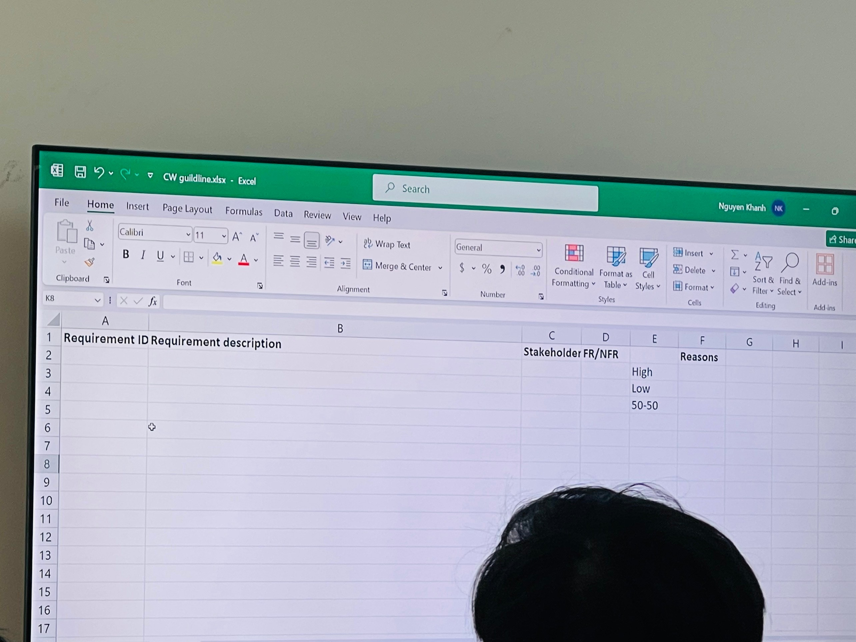

B2. Use the MoSCoW/Timebox rules to prioritise the requirements in your updated ‘high level requirements list’.

B2.1. Produce an updated ‘high level requirements list’ clearly showing the prioritisation you have given to each of your requirements.

B2.2 Explain how you set about prioritising the requirements and justify your reasons for the decisions that you made.

**Your answer to B2 should be in the region of 500 -750 words.**

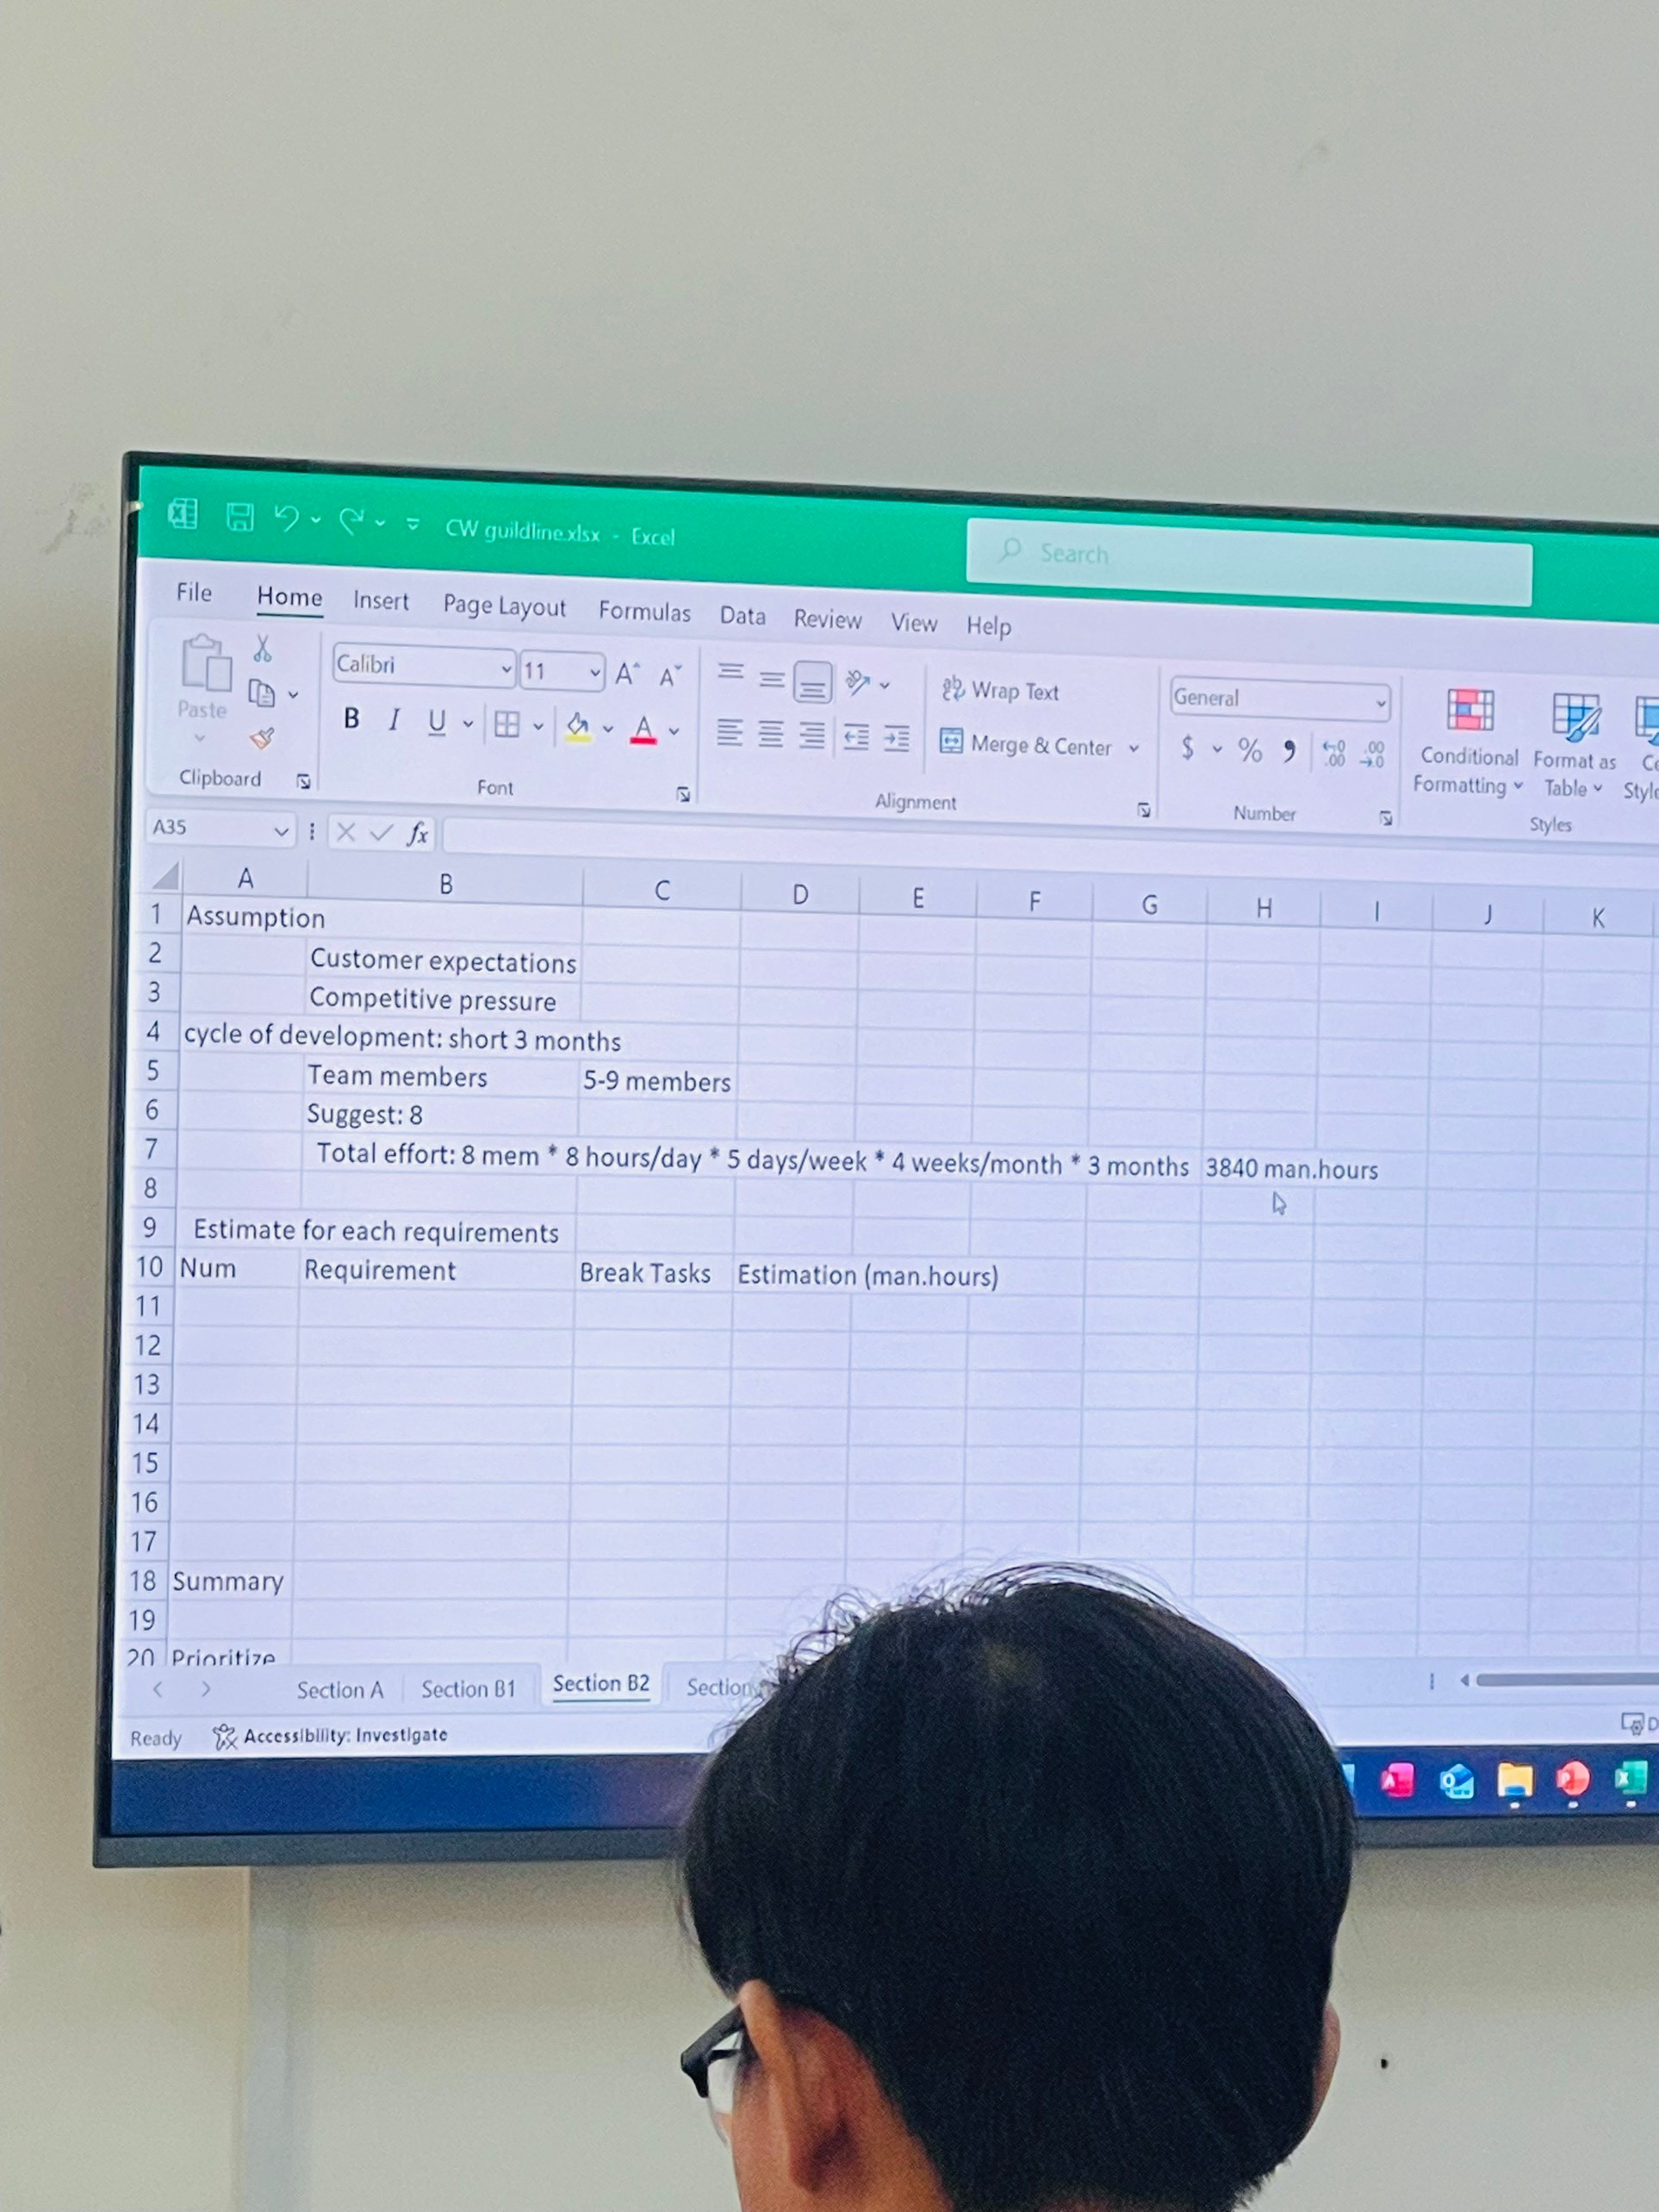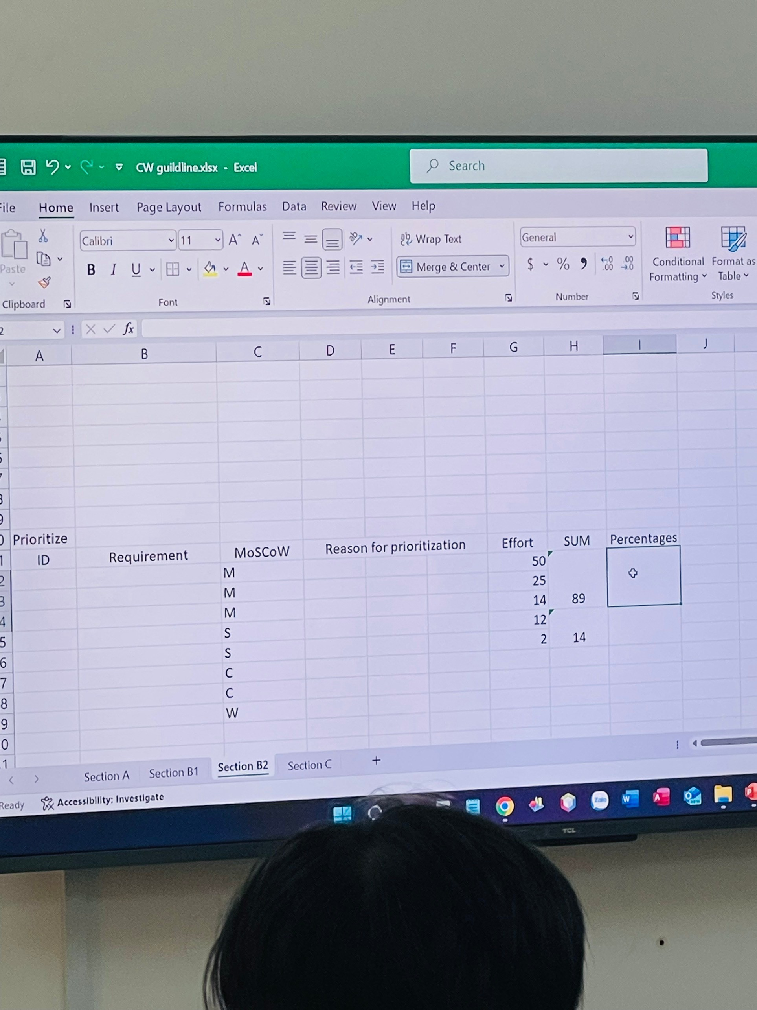

**Section C – Legal, Social, Ethical and Professional issues (30% of the marks)**

C1. **Green Groceries** personnel needs to start considering Legal, Social, Ethical, and Professional Issues (LSEPI) in relation to its day-to-day operations.Produce a management summary identifying Legal, Social, Ethical, and Professional issues that a system developer for the company would need to be aware of. Provide **one** practical examples from the case study that relate to **each** aspect of LSEPI identified.

**Your answer to C1 should be in the region of 500 words**

C2.Produce a management summary outlining the purpose of a professional body, such as the British Computer Society. As a part of this, provide a practical example for each of the **four** BCS Code of Conduct sections to illustrate how the professional body may guide the choices and decisions of their members.

**Your answer to C2 should be in the region of 500 words.**

**Conclusion and Assumptions – 5% (200 - 300 words approximately)**

**Harvard style and English proficiency – 5%**

**Grading Criteria**

|  |  |
| --- | --- |
| 80% + | * An **outstanding attempt** demonstrating a genuinely unique and a deep understanding of the requirements of the assignment. * Demonstrate an outstanding understanding of the issues surrounding the application of Agile based methods to a development environment. * Demonstrate exceptional understanding of high-level requirements analysis and MoSCoW prioritisation. * Apply the MoSCoW rules thoroughly, demonstrating an outstanding understanding of the need for incremental delivery. * Demonstrate an outstanding understanding of the DPA principles and the practical role of the Data controller. * Demonstrate an outstanding understanding of the role of the professional and, in particular, the BCS code of conduct. * A deeply impressive demonstration of research, organisation, initiative, analysis, and application, worthy of publication with the required referencing. |
| 70%- 79% | * An **excellent** attempt demonstrating a clear understanding of the requirements of the assignment. * Demonstrate a thorough understanding of the issues surrounding the application of Agile based methods to a development environment. * Demonstrate a thorough understanding of high-level requirements analysis and MoSCoW prioritisation. * Apply the MoSCoW rules sensibly, demonstrating a clear understanding of the need for incremental delivery. * Demonstrate a thorough understanding of the DPA principles and the practical role of the Data controller. * Demonstrate a thorough understanding of the role of the professional and, in particular, the BCS code of conduct. * Bring original thought to the argument; |
| 60%- 69% | * Demonstrate a **good to very good understanding** of the issues surrounding the application of Agile based methods to a development environment. * Demonstrate a good understanding of high-level requirements analysis and MoSCoW prioritisation. * Apply the MoSCoW rules sensibly, demonstrating a good understanding of the need for incremental delivery. * Demonstrate a good understanding of the DPA principles and the practical role of the Data controller. * Demonstrate a good understanding of the role of the professional and, in particular, the BCS code of conduct. * Bring some original thought to the argument; |
| 50%- 59% | * A **fair attempt** demonstrating an effective understanding of the assignment. * Demonstrate understanding of some of the issues surrounding current development methodology approaches. * Demonstrate understanding of some of the issues surrounding the application of Agile based methods to a development environment. * Demonstrate understanding of some the issues relating to high level requirements analysis and MoSCoW prioritisation. * Apply the MoSCoW rules in a sensible way demonstrating some understanding of the need for incremental delivery. * Demonstrate an understanding of the DPA principles and the practical role of the Data Controller. * Demonstrate an understanding of the role of the professional and, in particular, the BCS code of conduct. * Identify some practical examples relating to the above |
| 40%- 49% | * Demonstrate a **basic understanding** of the issues surrounding the application of Agile based methods to a development environment. * Demonstrate a basic understanding of high-level requirements analysis and MoSCoW prioritisation. * Apply the MoSCoW rules in a basic way. * Demonstrate a basic understanding of the DPA principles and the practical role of the Data controller. * Demonstrate a basic understanding of the role of the professional and, in particular, the BCS code of conduct. |
| Below 39% | * Demonstrate a poor understanding of the issues surrounding the application of Agile based methods to a development environment. * Poor understanding of the requirements of the assignment. * Possibly some confusion and much irrelevant material. * Lack of clarity on the MoSCoW rules. * Demonstrate an inadequate understanding of the DPA principles and the practical role of the Data controller. * Demonstrate inadequate understanding of the role of the professional and, in particular, the BCS code of conduct. |